**Project Design Phase-II**

**Data Flow Diagram & User Stories**

| Date | 20 May 2023 |
| --- | --- |
| Team ID | NM2023TMID17565 |
| Project Name | Intelligent Garbage Classification Using Deep Learning |

**Data Flow Diagrams:**

A Data Flow Diagram (DFD) is a traditional visual representation of the information flows within a system. A neat and clear DFD can depict the right amount of the system requirement graphically. It shows how data enters and leaves the system, what changes the information, and where data is stored.

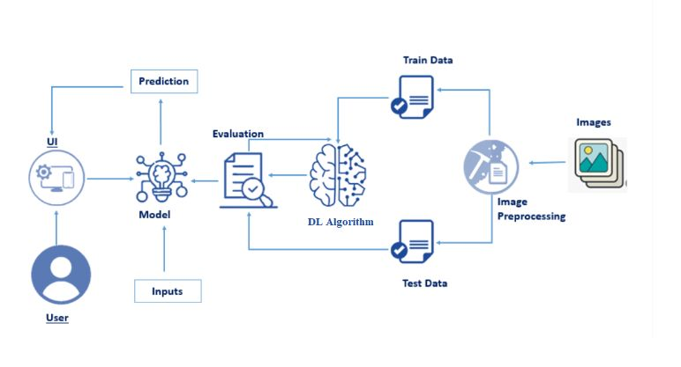

**User Stories**

Use the below template to list all the user stories for the product.

| **User Type** | **User Story Number** | **User Story / Task** | **Acceptance criteria** |
| --- | --- | --- | --- |
| Customer (Mobile user) | USN-1 | As a homeowner, I want to have a user-friendly mobile app that allows me to take pictures of garbage items and receive real-time classification results, helping me make informed decisions about recycling and waste disposal. | The mobile app should be available for both iOS and Android platforms. |
|  | USN-2 | As a waste collection truck driver, I want a user-friendly interface on the truck's onboard system that provides real-time guidance on which bins to place collected garbage items, optimizing my collection route and reducing sorting errors. | The onboard system should have a clear and intuitive interface, easily accessible to the truck driver during garbage collection rounds. |
| Customer (Web user) |  | As a customer web user, I want to have a seamless experience on the website for accessing information about the garbage classification system and submitting feedback or inquiries. | The website should have a user-friendly interface with clear navigation and intuitive design. |
| Customer Care Executive |  | As a customer care executive, I want a customer management system that allows me to efficiently handle customer inquiries, track feedback, and provide timely responses. | The customer management system should have a user-friendly interface for customer care executives to log in and access customer inquiries and feedback. |
| Administrator |  | As a system administrator, I want to receive automatic alerts and notifications whenever the system experiences downtime or encounters critical errors, so I can quickly address the issues and minimize service disruptions. | The system should send email or push notifications to the system administrator when system downtime exceeds 5 minutes. |